A

**PROJECT REPORT ON**

**ONLINE EXAMINATION SYSTEM**

SUBMITTED

IN PARTIAL FULFILLMENT OF THE REQUIREMENTS

FOR THE DEGREE OF

**M.SC (COMPUTER APPLICATION)**

BY

**MR. VIKAS SAHU**

**(PERMANENT REG. NO.)**

**40720601296**

VIKAS COLLEGE STUDY CENTRE (MUMBAI, VIKHROLI)

TILAK MAHARASHTRA VIDYAPEETH, PUNE.

(2021 – 2022)



# TILAK MAHARASHTRA VIDYAPEETH, PUNE

(DEEMED UNDER SECTION 3 OF UGC ACT 1956 VIDE NOTIFICATION NO. F 9-19/85-U3 DATED 24TH APRIL 1987 BY THE GOVERNMENT OF INDIA)

#### VIDYAPEETH BHAVAN, GULTEKADI, PUNE- 411 037

**CERTIFICATE**

THIS IS TO CERTIFY THE PROJECT TITLED

**“ONLINE EXAMINATION SYSTEM”** IS A BONAFIDE WORK CARRIED OUT BY

**MR. VIKAS SAHU**

(PERMANENT REG. NO. 40720601296)

BY STUDENT OF M.Sc. (COMPUTER APPLICATION)

SEMESTER 4TH

UNDER TILAK MAHARASHTRA VIDYAPEETH IN THE YEAR 2022

EXAMINER INTERNAL EXAMINER EXTERNAL HEAD OF THE DEPARTMENT

DATE:

PLACE: SEAL

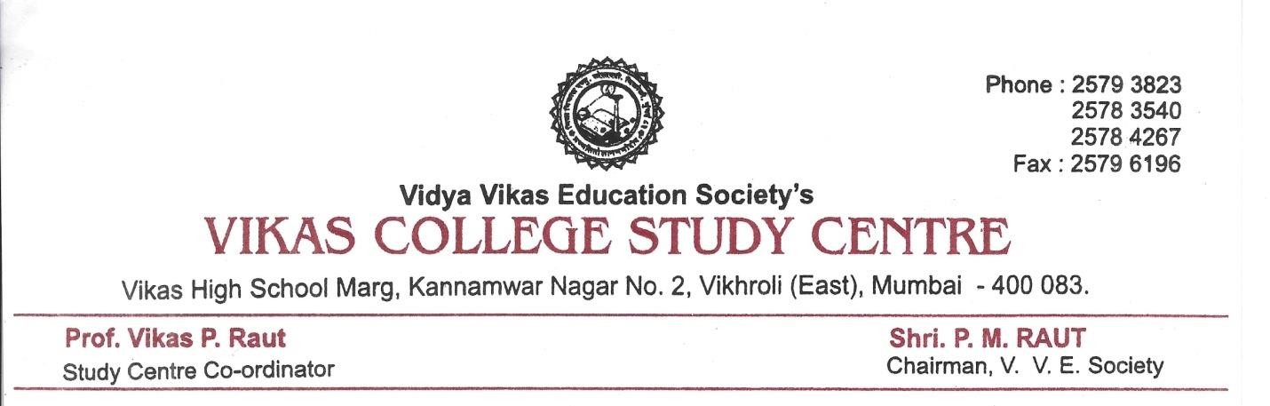

**GUIDE CERTIFICATE**

THIS IS TO CERTIFY THAT THE PROJECT “ONLINE EXAMINATION SYSTEM” HAS BEEN SATISFACTORILY COMPLETED BY

**MR. VIKAS SAHU**

PERMANENT REG. NO. 40720601296

TOWARD THE PARTIAL FULFILLMENT OF THE

‘M.Sc. (COMPUTER APPLICATION),

FOR THE ACADEMIC YEAR (2021-2022) AT VIKAS COLLEGE, VIKHROLI

TILAK MAHARASHTRA VIDYAPEETH, PUNE

(FACULTY OF DISTANCE EDUCATION),

###### AND IT IS APPROVED.

PROJECT GUIDE EXAMINER HEAD OF DEPT.

**MR. VIKAS RAUT**

**ACKNOWLEDGEMENT**

Online examinations are an important method of evaluating the success potential of students. This research effort the individuals under consideration were students who would be enrolling in computer courses or Technologies Registrations. A prototype of a web-based placement examination system is described from the standpoint of the research effort, end user, and software development.

An on-line educational system including exam processing and electronic journal features. An instructor builds a course-based questions which on-line contain in identification of assignments. Which are compiled into an on-line exam syllabus?

Users enrolled in the platform may access the electronic details they provided and perform various functions with the on-line educational system in order to participate in the on-line examinations. Users can receive an on-line exam, having multimedia content, for the course, and they can electronically provide answers for the exam. And after Completion of their duration of exam they are provided the grade or marks secured in their examinations.

# **ONLINE EXAMINATION SYSTEM**

**INTRODUCTION**

Today the Online *Examination System in PHP* has become a fast-growing examination method because of its speed and accuracy. It also needs less manpower to execute the examination. Almost all organizations now-a-days, are conducting their objective exams by online examination system, it saves students time in examinations. Organizations can also easily check the performance of the student that they give in an examination. As a result of this, organizations are releasing results in less time. It also helps the environment by saving paper. According to today’s requirement.

Brief overview of the technology: *Online Examination System in PHP*

Front end: HTML, CSS, JavaScript

1. HTML: HTML is used to create and save web documents. E.g., Notepad/Notepad++
2. CSS: (Cascading Style Sheets) Create attractive Layout
3. Bootstrap: responsive design mobile friendly site
4. JavaScript: it is a programming language, commonly used with web browsers.

Back end: PHP, MySQL

1. PHP: Hypertext Preprocessor (PHP) is a technology that allows software developers to create dynamically generated web pages, in HTML, XML, or other document types, as per client request. PHP is open-source software.
2. MySQL: MySQL is a database, widely used for accessing querying, updating, and managing data in databases.

**Requirement Specifications:**

|  |  |
| --- | --- |
| Name of Component | Specification |
| Operating System | Windows 7 and above |
| Language Used | PHP, CSS, HTML, Bootstrap, JavaScript, SQL |
| Database | SQL Server |
| Development Platform | Sublime text 3 and Xampp server |
| Processor | Pentium iv processor or above |

**INDEX**

|  |  |  |
| --- | --- | --- |
| **SR.NO.** | **TOPIC NAME** | **PAGE NO** |
| **1** | **INTRODUCTION** | **7** |
| **2** | **FEATURES OF PROJECT** | **8** |
| **3** | **SCOPE OF PROJECT** | **9** |
| **4** | **SYSTEM REQUIREMENT** | **10** |
| **5** | **ANALYSIS** | **11** |
| **6** | **TECHNOLOGY DESCRIPTION** | **12** |
| **7** | **OBJECT & SCOPE OF PROJECT** | **16** |
| **8** | **PURPOSE OF SYSTEM** | **17** |
| **9** | **FEASIBILITY STUDY** | **18** |
| **10** | **PROBLEM WITH EXISTING SYSTEM** | **19** |
| **11** | **LIMITATION OF EXISTING SYSTEM** | **20** |
| **12** | **SDLC STUDY** | **21** |
| **13** | **WATERFALL MODEL** | **25** |
| **14** | **DETAILED LIFE CYCLE OF PROJECT** | **26** |
| **15** | **UML DIAGRAM** | **28** |
| **GANTT CHART**  **PERT CHART**  **ER DIAGRAM**  **DATA FLOW DIAGRAM**  **ACTIVITY DIAGRAM**  **OBJECT DIAGRAM**  **SEQUENCE DIAGRAM**  **CLASS DIAGRAM**  **USE CASE DIAGRAM** | **28** |
| **30** |
| **32** |
| **34** |
| **37** |
| **39** |
| **41** |
| **43** |
| **45** |
| **16** | **SCEERNSHOTS** | **47** |
| **17** | **FUTURE WORK & LIMITATION** | **51** |
| **18** | **CONCLUSION** | **52** |
| **19** | **BIBILOGRAPHY** | **53** |

**1. INTRODUCTION**

**PROJECT DETAIL**

Online examinations contents providers to focus on creating effective assessment questions and focusing on exam’s feedback delivery to students. In the paper we present techniques that are pertinent to the elements of assessment process: answers submission, computerized grading, and feedback after submission.

As the modern organizations are automated and computers are working as per the instructions, it becomes essential for the coordination of human beings, commodity and computers in a modern organization.

The Application Is Implemented in Php and Consists of Two Main Components:

* ADMIN.
* STUDENT SIDE.

The administrators, instructor, Students who are attending for online examination can communicate with the system through this project, thus facilitating effective implementation and monitoring of various activities of Online Examinations like conducting Exams as per scheduled basis and delivering result to that particular use or student. And the details of students who attempted Online Examination are maintained at administrator.

**2. FEATURES OF PROJECT**

* Login system must be present and secured by password.
* Ability to save the answer given by the candidate along with the question.
* Answer checking system should be available.
* Candidate should able to view ranking.
* Candidate should able to view while test is pending and while is not.
* Candidate should able to use feedback form.
* Could Update Profile.
* Log out after the over.
* Admin Panel.
* Admin should able to create test.
* Admin should able to view all result of all candidate.
* Admin should able to view all Feedback of all candidate.
* Admin should able to view all result of all candidate.
* Admin should able to view ranking.
* Admin should able to delete feedback.

**3. Scope of Project**

The scope of our project is vast. This system conducts exams effortlessly. It Reduces exams anxiety amongst test takers. Online examination software promotes social interaction between the test taker and experts. It Prevents cheatings. It provides Safe and secures data.

The scope of the online examination system is that it reduces administrative burden. The main advantages of the online examination system are given below as,

* Online Examination System is a computerized system which gives instant results and also saves
* It fully automates the previous manual process of taking written
* It is implemented by web based online examination software or through Intranet

It decreases the need of supervision during the exam is being examine or taken using web based Online Examination System gives a high level of clarity as opposite of traditional method. Most of Online Examination System gives the result and instantly

* In high school, Online Examination
* System is able to reduce the workload of teachers by using automated test paper exams and marking
* Students can study independently for example at home.
* The amount of time given at a particular question gives you the ability of “Quick Learning Quick-thinking “.
* The data in Online Examination System is regenerated repeatedly so that students have access to new data.

**4. SYSTEM OF REQUIREMENT**

4.1 the hardware requirements Online *Examination System* portal are

* Processor: Pentium iv processor
* Hard disk: 80 GB hard disk.
* Ram: 512 mb and above

4.2 the software specifications are

* Operating system: window 7 and above
* Html, CSS, PhP (front end)
* MySQL (back end)
* Php (server-side programming)
* Xampp server

**5. ANALYSIS**

**EXISTING SYSTEM**

Existing system is a manual one in which users are maintaining books to store the information like Student Details, Instructor Details, Schedule Details and feedbacks about students who attempted exam as per schedule. It is very difficult to maintain historical data.

**DISADVANTAGES:**

The following drawbacks of existing system emphasize the need for computerization:

1. A lot of copies of question papers have to be made

2. A lot of correction work hence delay in giving the results

3. A lot of tabulation work for each subject results

**PROPOSED SYSTEM**

This application is used to conduct online examination. The students can sit at individual terminals and login to write the exam in the given duration. The questions have to be given to the students. This application will perform correction, display the result immediately and also store it in database. This application provides the administrator with a facility to add new exams.

This application provides the instructor add questions to the exam, modify questions in the exam in a particular exam. This application takes care of authentication of the administrator, Instructor as well as the student.

**OBJECTIVE OF THE SYSTEM**

The objective of the Online Examination Tool is to provide better information for the users of this system for better results for their maintenance in student examination schedule details and grading details

**6. TECHNOLOGY DESCRIPTION**

**PHP**

The php hypertext preprocessor (php) is a programming language that allows web developers to create dynamic content that interacts with databases. Php is basically used for developing web-based software applications. This tutorial helps you to build your base with php.

Php started out as a small open-source project that evolved as more and more people found out how useful it was. Rasmus leadoff unleashed the first version of php way back in 1994.

Php is a must for students and working professionals to become a great software engineer specially when they are working in web development domain. I will list down some of the key advantages of learning php:

* Php is a recursive acronym for "php: hypertext preprocessor".
* Php is a server-side scripting language that is embedded in html. It is used to manage dynamic content, databases, session tracking, even build entire e-commerce sites.
* It is integrated with a number of popular databases, including mysql, postgresql, oracle, sybase, informix, and microsoft sql server.
* Php is pleasingly zippy in its execution, especially when compiled as an apache module on the unix side. The mysql server, once started, executes even very complex queries with huge result sets in record-setting time.
* Php supports a large number of major protocols such as pop3, imap, and ldap. Php4 added support for java and distributed object architectures (com and corba), making n-tier development a possibility for the first time.
* Php is forgiving: php language tries to be as forgiving as possible.
* Php syntax is c-like.

## CHARACTERISTICS OF PHP

Five important characteristics make php's practical nature possible −

* Simplicity
* Efficiency
* Security
* Flexibility
* Familiarity

## MYSQL INTRODUCTION

There are a large number of database management systems currently available, some commercial and some free.  
Some of them: Oracle, Microsoft Access, MySQL and PostgreSQL.  
These database systems are powerful, feature-rich software, capable of organizing and searching millions of records at very high speeds.

### Understanding Databases, Records, and Primary Keys

Every Database is composed of one or more tables.  
These Tables, which structure data into rows and columns, Impose organization on the data.

The records in a table(below) are not arranged in any particular order.  
To make it easy to identify a specific record, therefore, it becomes necessary

### Standing Relationships and Foreign Keys (RDBMS)

You already know that a single database can hold multiple tables.  
In a Relational database management system (RDBMS), these tables can be linked to each other by one or more common fields, called ****foreign keys****.

### Database administrator (DBA)?

Database administrator is the super user of database, he has unrestricted rights and privileges to access database, grant permission to other database users.

### Database user (DBU)?

Database user is the person who uses the database in a restricted privilege, provided by database administrator.

**DATABASE TABLES:**

**USER REG TABLE**

|  |  |  |  |
| --- | --- | --- | --- |
| NAME | NULL/NOTNULL | TYPE | KEY |
| ID | NOTNULL | INT | PRIMARYKEY |
| NAME | NULL | VARCHAR(50) |  |
| DOB | NULL | DATETIME |  |
| GENDER | NULL | VARCHAR(10) |  |
| BRANCH | NULL | VARCHAR(20) |  |
| COLLEGE | NULL | VARCHAR(50) |  |
| UID | NULL | VARCHAR(50) |  |
| PWD | NULL | VARCHAR(20) |  |
| RPWD | NULL | VARCHAR(20) |  |
| UTYPE | NULL | VARCHAR(20) |  |
| QUE | NULL | VARCHAR(500) |  |
| ANS | NULL | VARCHAR(500) |  |

**TRUE/FALSE BASED QUESTION TABLE**

|  |  |  |  |
| --- | --- | --- | --- |
| NAME | NULL/NOTNULL | TYPE | KEY |
| ID | NOTNULL | INT | PRIMARYKEY |
| QUE | NULL | VARCHAR(500) |  |
| AW | NULL | VARCHAR(500) |  |

**TRUE/FALSE BASED ANSWER TABLE**

|  |  |  |  |
| --- | --- | --- | --- |
| NAME | NULL/NOTNULL | TYPE | KEY |
| ID | NOTNULL | INT | FOREIGNKEY |
| AW | NULL | VARCHAR(500) |  |

**OPTIONS BASED QUESTION TABLE**

|  |  |  |  |
| --- | --- | --- | --- |
| NAME | NULL/NOTNULL | TYPE | KEY |
| QID | NOTNULL | INT | PRIMARYKEY |
| QN | NULL | VARCHAR(500) |  |
| OPTIONS1 | NULL | VARCHAR(100) |  |
| OPTIONS2 | NULL | VARCHAR(100) |  |
| ANSWER | NULL | VARCHAR(100) |  |

**OPTIONS BASED ANSWERS**

|  |  |  |  |
| --- | --- | --- | --- |
| NAME | NULL/NOTNULL | TYPE | KEY |
| QID | NOTNULL | INT | FOREIGNKEY |
| ANSWER | NULL | VARCHAR(10) |  |

**ALL STUDENT MARKS**

|  |  |  |  |
| --- | --- | --- | --- |
| NAME | NULL/NOTNULL | TYPE | KEY |
| ID | NULL | INT |  |
| MARKS | NULL | INT |  |

**EXAM SCHEDULE**

|  |  |  |  |
| --- | --- | --- | --- |
| NAME | NULL/NOTNULL | TYPE | KEY |
| ENAME | NULL | VARCHAR(30) |  |
| EDATE | NULL | DATETIME |  |

**7. OBJECT & SCOPE OF PROJECT**

The Online examinations portal website automation has been designed keeping in mind the many of the objective of project to be fulfilled.

The project was developed keeping in mind that it should be easily understandable easy to use, easy to learn.

**OBJECTIVES OF THE PROJECT**

* It should be easy to understand.
* It should be convenient to handle.
* Data should be easily accessible.
* Data monitoring should be effective.
* Different database should be connected to each other.
* Change in one entry should bring change in other entries in other related tables.
* Student can Give Exam
* Student can view marks as soon is done.
* Examiner can add new subject and tests.
* Examiner can view list of students
* Examiner can view mark of all student
* Multiple candidates can take the exam at the same time
* It displays the results after the question is submitted
* It handles MCQ, True false types of questions.
* The faculties can set the time trigger for their exams to be activated
* The faculties insert the questions by using GUI

**8. PURPOSED SYSTEM**

* To provide best and easy service all Student and Examiner.
* To provide value for money service in market.
* To reduced time consuming to view result.
* To reduce to paper work.
* It will have a comfortable and user-friendly GUI.
* Also, the system is intended to take input from the user.
* This procedure is fast and modern.
* Time saving since all the details information is stored in this system it enables in significant reduction in the number of man-hours taken up for the storage and the retrieval of the information as it removes the large register from the scene.
* No need visit examination hall or college.
* Easy to manage test’s online
* Easy to create a test.

**9. FEASIBILITY STUDY**

There are several types of feasibility depending on the aspect they cover. Some important feasibility is as follows:

**TECHNICAL FEASIBILITY**

The technical feasibility study basically centers on alternatives for hardware, software and design approach to determine the functional aspects of the system. This project on Online Examination will be platform independent since it is being coded in PHP language (using notepad++), HTML is will be used to create web pages and MySQL database will be used for storing data and it would be very easy to set up the system in the current environment as the application is web based it does not require to be installed on every machine. It would be installed in ISP (internet service provides) server.

**OPERATIONAL FEASIBILITY**

Operational Feasibility is a measure of how people are able to work with system. This type of feasibility demands if the system will work when developed and installed. Since this website is very user friendly so users will find it comfortable to work on this site.

**ECONOMIC FEASIBILITY**

Economic analysis is the most frequently used evaluating the effectiveness of proposed system, more commonly known as Benefit analysis. The Benefit analysis is to determine benefits and savings which are expected from candidate system and compare them with cost. If the benefits are more than the cost, then decision is made to design and implement the system. The cost and benefits may be direct or indirect and tangible or intangible. The benefits of this project are more than the cost so the system is economically feasible.

**10. PROBLEM WITH EXISTING SYSTEM**

The current working of service center is manually. There for a current is time consuming for customer and also it is very costly, because it involves a lot of staff member, paper work etc.to manually handle such a system was very difficult task.

**CURRENTLY THE SERVICE CENTER HAVE PROBLEM BE LIKE:**

* Less number of service center able in each location.
* There is different type of service center are available in market. For e.g.-brand like dell, ASUS and acer etc. Dell will not repair a laptop of ASUS and acer will not repair of laptop of dell. Their customer need service center provides all laptops and desktops repairing service and product buy function.
* Now days existing service are varied time consuming.
* Dealing with customer is not proper.
* Not a value for money product and service.

**11. LIMITATION OF EXISTING SYSTEM**

* **TIME CONSUMING:**

As the records are to be manually maintained it consumes a lot of time. each student has visit examination hall.

* **LOCATION OF EXAMINATION CENTER:**

Less examination center available in market.

* **DIFFERENT EXAMINATION HALL’S:**

Now day’s student has to collect hall ticket and searching for exam hall

* **No essay type questions**
* **A lot of paper work in required for examiner like creating question set**

**Paper sheet of student**

* **No Facility for the Disabled: the system has any options available by which a physically disabled user can use the system. If the user is blind or deaf the system has no sound response or Braille response facility.**
* **User interface is only in English, no other language option is available.**
* **No guest facility: User can login only with his or her assigned username and password**

**12. SDLC STUDY**

**SDLC AND PHASES**

The systems development life cycle (sdlc), also referred to as the application development life-cycle, is a term used in systems engineering, information systems and software engineering to describe a process for planning, creating, testing, and deploying an information system. The systems development life-cycle concept applies to a range of hardware and software configurations, as a system can be composed of hardware only, software only, or a combination of both.

A systems development life cycle is composed of a number of clearly defined and distinct work phases which are used by systems engineers and systems developers to plan for, design, build, test, and deliver information systems. Like anything that is manufactured on an assembly line, an sdlc aims to produce high-quality systems that meet or exceed customer expectations, based on customer requirements, by delivering systems which move through each clearly defined phase, within scheduled time frames and cost estimates. Computer systems are complex and often (especially with the recent rise of service-oriented architecture) link multiple traditional systems potentially supplied by different software vendors. To manage this level of complexity, a number of sdlc models or methodologies have been created, such as "waterfall"; "spiral"; "agile software development"; "rapid prototyping"; "incremental"; and "synchronize and stabilize".

The sdlc adheres to important phases that are essential for developers, such as planning, analysis, design, and implementation, and are explained in the section below. It includes evaluation of present system, information gathering, and feasibility study and request approval. A number of sdlc models have been created: waterfall, fountain, spiral, build and fix, rapid prototyping, incremental, synchronize and stabilize. The oldest of these, and the best known, is the waterfall model: a sequence of stages in which the output of each stage becomes the input for the next. These stages can be characterized and divided up in different ways, including the following:

**PRELIMINARY ANALYSIS:**

The objective of phase 1 is to conduct a preliminary analysis, propose alternative solutions, describe costs and benefits and submit a preliminary plan with recommendations.

Conduct the preliminary analysis: in this step, you need to find out the organization's objectives and the nature and scope of the problem under study. Even if a problem refers only to a small segment of the organization itself, you need to find out what the objectives of the organization itself are. Then you need to see how the problem being studied fits in with them.

Propose alternative solutions: in digging into the organization's objectives and specific problems, you may have already covered some solutions. Alternate proposals may come from interviewing employees, clients, suppliers, and/or consultants. You can also study what competitors are doing. With this data, you will have three choices: leave the system as is, improve it, or develop a new system.

Describe the costs and benefits.

**SYSTEMS ANALYSIS, REQUIREMENTS**

**DEFINITION:**

Defines project goals into defined functions and operation of the intended application. It is the process of gathering and interpreting facts, diagnosing problems and recommending improvements to the system. Analyzes end-user information needs and also removes any inconsistencies and incompleteness in these requirements.

**A SERIES OF STEPS FOLLOWED BY**

**THE DEVELOPER ARE:**

Collection of facts: end user requirements are obtained through documentation, client interviews, observation and questionnaires,

Scrutiny of the existing system: identify pros and cons of the current system in-place, so as to carry forward the pros and avoid the cons in the new system.

Analyzing the proposed system: solutions to the shortcomings in step two are found and any specific user proposals are used to prepare the specifications.

**SYSTEMS DESIGN:**

Describes desired features and operations in detail, including screen layouts, business rules, process diagrams, pseudocode and other documentation.

**DEVELOPMENT:**

The real code is written here.

**INTEGRATION AND TESTING:**

Brings all the pieces together into a special testing environment, then checks for errors, bugs and interoperability.

**ACCEPTANCE, INSTALLATION**

**DEPLOYMENT:**

The final stage of initial development, where the software is put into production and runs actual business.

**MAINTENANCE:**

During the maintenance stage of the sdlc, the system is assessed to ensure it does not become obsolete. This is also where changes are made to initial software. It involves continuous evaluation of the system in terms of its performance.

**EVALUATION:**

Some companies do not view this as an official stage of the sdlc, while others consider it to be an extension of the maintenance stage, and may be referred to in some circles as post-implementation review. This is where the system that was developed, as well as the entire process, is evaluated. Some of the questions that need to be answered include: does the newly implemented system meet the initial business requirements and objectives? Is the system reliable and fault-tolerant? Does the system function according to the approved functional requirements? In addition to evaluating the software that was released, it is important to assess the effectiveness of the development process. If there are any aspects of the entire process, or certain stages, that management is not satisfied with, this is the time to improve. Evaluation and assessment are a difficult issue. However, the company must reflect on the process and address weaknesses

**ISPOSAL:**

In this phase, plans are developed for discarding system information, hardware and software in making the transition to a new system. The purpose here is to properly move, archive, discard or destroy information, hardware and software that is being replaced, in a manner that prevents any possibility of unauthorized disclosure of sensitive data. The disposal activities ensure proper migration to a new system. Particular emphasis is given to proper preservation and archival of data processed by the previous system. All of this should be done in accordance with the organization's security requirements.

**SDLC DIAGRAM:**

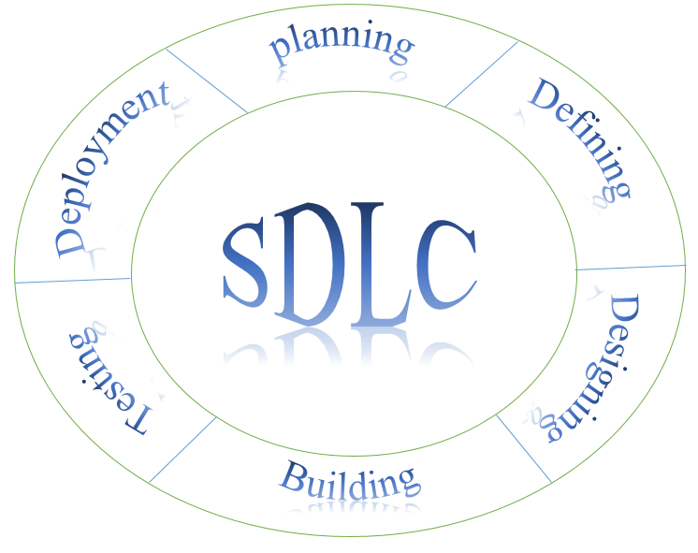

SDLC DIAGRAM

**13. WATERFALL MODAL**

The waterfall model was first process model to be introduced. It is also referred to as a linear sequential life cycle model. It is very simple to understand and use. In a waterfall model, each phase must be completed before the next phase can begin and there is no overlapping in the phases.

Waterfall model is the earliest sdlc approach that was used for software development.

The waterfall model illustrates the software development process in a linear sequential flow; hence it is also referred to as a linear-sequential life cycle model. This means that any phase in the development process begins only if the previous phase is complete. In waterfall model phases do not overlap.

**WATERFALL MODEL DESIGN**

Waterfall approach was first sdlc model to be used widely in software engineering to ensure success of the project. In "the waterfall" approach, the whole process of software development is divided into separate phases. In waterfall model, typically, the outcome of one phase acts as the input for the next phase sequentially.

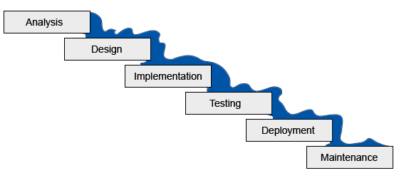**WATERFALL MODEL**:

*WATERFALL MODEL*

**14. DETAILED LIFE CYCLE OF PROJECT**

**SYSTEM DEVELOPMENT PROCESS**

A development process consists of various phases each ending with a defines output the main reason for having a phased process is that it breaks the problem of developing software into successfully performing a set of phases each handling a different concern of software. Requirement analysis

* Requirement analysis is done in order to understand the problem the software system is to solve the goal of the requirement in also software requirement specification document.
* There are two major activates in this phase problem understanding or analysis and requirement specification in the problem analysis the aim is to understand the problem and its context and their requirement of the new system is to be developed.
* Once the problem is analyzed and the essential understood their requirement must be specified in the requirement must be specified in the requirement specification document the requirement must specify all functional performance requirement the format of inputs outputs and all deign constraints that exist due to political environment and security reasons.

**SOFTWARE DESIGN**

* The purpose of the design phase is to plan a solution of the problem specified by the to the solution domain. Requirements documents. This phase is the first step in moving from the problem domain.
* The design activity often results in three separate outputs.
* Architecture design- it focuses on looking at a system as a combination of many different components, and how they interact with each other to produce the desired results.
* High level design. It identifies the module that should be built for developing the developing the system and the specifications of these modules.
* Design level design- the internal logic of each of the modules.

**CODING**

* The goal of the coding phase is to translate the design of the system into code in a given

Programming language. For a given design, the aim in this phase is to implement the design in the best possible way.

* The coding phase affects both testing and maintenance profoundly. Well-written code can reduce testing and maintenance effort. The testing and maintenance cost of software are Much higher than coding cost. Hence, during coding, the focus should be developing programs that are easy to read & understand, and not simply developing program that are easy to write. Simplicity and clarity should be strived for during the coding phase.

**TESTING**

* Testing is the major quality control measure used during software development. Its basic Function is to detect defects in the software. The goal of testing is to uncover requirement Design & coding errors in the program.
* The starting point of testing is unit testing, where the different modules or components are tested individually.
* The modules are integrated into the system; integration testing is performed, which

Focuses on testing the interconnection between modules.

* After the system is put together, system testing is performed. Here, the system is tested

Against system requirements to see if all the requirements are met & if the system is performed has specified by their requirement.

* Finally, the acceptance testing is performed to demonstrate to the client, on real-life data

Of the client, the operation of the system.

* Then for different test, a test case specification document is produced which lists all the

Different test cases, together with the expected outputs

* The final output of the testing phase is the test report and the error report, or set of such report’s cases
* Each test report contains the set of test cases & the result of executing the code with these test cases.

**15. UML DIAGRAM**

**GANTT CHART**

A Gantt chart is a type of bar chart, adapted by Karol adamiecki in 1896 and independently by henry Gantt in the 1910s that illustrates a project schedule. Gantt charts illustrate the start and finish dates of the terminal elements and summary elements of a project. Terminal elements and summary elements comprise the work breakdown structure of the project. Modern Gantt charts also show the dependency (i.e., precedence network) relationships between activities. Gantt charts can be used to show current schedule status using percent-complete shadings and a vertical "today" line as shown here.

Although now regarded as a common charting technique, Gantt charts were considered revolutionary when first introduced. This chart is also used in information technology to represent data that has been collected.

As Gantt chart is a horizontal bar chart developed as a production control tool in 1917 by henry l. Gantt, an American engineer and social scientist. Frequently used in project management, a Gantt chart provides a graphical illustration of a schedule that helps to plan, coordinate, and track specific tasks in a project.

A Gantt chart, commonly used in project management, is one of the most popular and useful ways of showing activities (tasks or events) displayed against time. On the left of the chart is a list of the activities and along the top is a suitable time scale. Each activity is represented by a bar; the position and length of the bar reflects the start date, duration and end date of the activity. This allows you to see at a glance:

* What the various activities are.
* When each activity begins and ends.
* How long each activity is scheduled to last.
* Where activities overlap with other activities, and by how much.
* The start and end date of the whole project.

to summarize, a Gantt chart shows you what has to be done (the activities) and when (the schedule).

**GANTT CHART:**

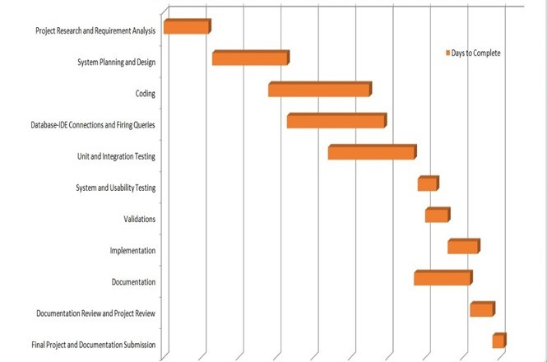

**PERT CHART**

A pert chart is a project management tool used to schedule, organize and coordinate tasks within a project. Pert stands for program evaluation review technique, a methodology developed by the us’ navy in the 1950s to manage the Polaris submarine missile program. A similar methodology, the critical path method (cpm) was developed for project management in the private sector at about the same time.

A pert chart presents a graphic illustration of a project as a network diagram consisting of numbered nodes (either circles or rectangles) representing events, or milestones in the project linked by labeled vectors (directional lines) representing tasks in the project. The direction of the arrows on the lines indicates the sequence of tasks. In the diagram, for example, the tasks between nodes 1, 2, 4, 8, and 10 must be completed in sequence. These are called dependent or serial tasks. The tasks between nodes 1 and 2, and nodes 1 and 3 are not dependent on the completion of one to start the other and can be undertaken simultaneously. These tasks are called parallel or concurrent tasks. Tasks that must be completed in sequence but that don't require resources or completion time are considered to have event dependency. These are represented by dotted lines with arrows and are called dummy activities. For example, the dashed arrow linking nodes 6 and 9 indicates that the system files must be converted before the user test can take place, but that the resources and time required to prepare for the user test (writing the user manual and user training) are on another path. Numbers on the opposite sides of the vectors indicate the time allotted for the task.

The pert chart is sometimes preferred over the Gantt chart, another popular project management charting method, because it clearly illustrates task dependencies. On the other hand, the pert chart can be much more difficult to interpret, especially on complex projects. Frequently, project managers use both techniques.

**PERT CHART:**

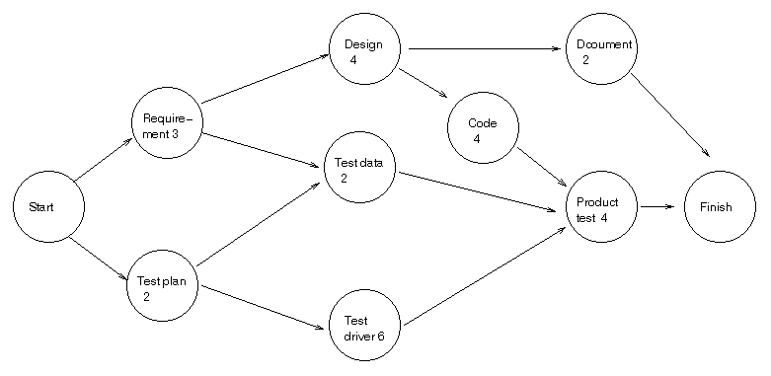*PERT CHART*

**ER DIAGRAM**

The entity-relationship data model (erd) perceives the real world as consisting of basic objects, called entity & relationship among these objects.

It was developed to facilitate database design by allowing specification of an enterprise schema, which represents overall logical structure of a database. The erd model is very useful in mapping the meaning & interactions of the outside world enterprises onto a conceptual schema.

The erd model consists of the following major components

* Ellipse which represents attributes.
* Rectangles which represent entity-sets.
* Diamonds which represent the relationship sets.
* Lines which link attributes to entity sets to relationship sets.

**ER-DIAGRAM:**

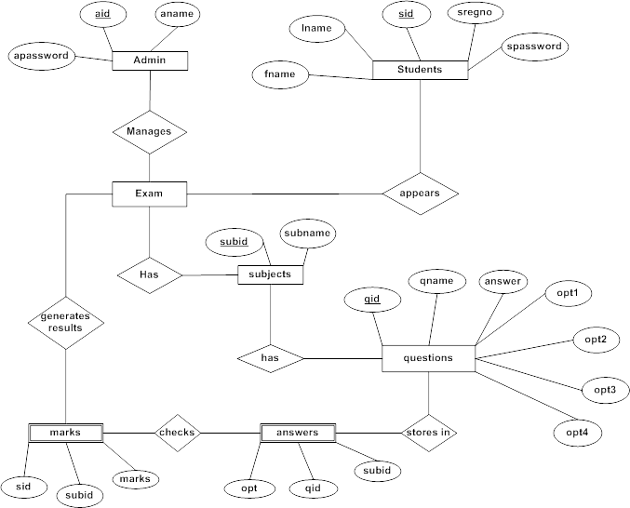*ER-DIAGRAM*

**DATA FLOW DIAGRAMS:**

The DFD takes an input-process-output view of a system i.e. Data objects flow into the software, are transformed by processing elements, and resultant data objects flow out of the software.

Data objects represented by labeled arrows and transformation are represented by circles also called as bubbles. DFD is presented in a hierarchical fashion i.e. The first data flow model represents the system as a whole. Subsequent DFD refine the context diagram (level 0 DFD), providing increasing details with each subsequent level.

The DFD enables the software engineer to develop models of the information domain & functional domain at the same time. As the DFD is refined into greater levels of details, the analyst performs an implicit functional decomposition of the system. At the same time, the DFD refinement results in a corresponding refinement of the data as it moves through the process that embody the applications.

A context-level DFD for the system the primary external entities produce information for use by the system and consume information generated by the system. The labeled arrow represents data objects or object hierarchy.

**RULES FOR DFD:**

* Fix the scope of the system by means of context diagrams.
* Organize the DFD so that the main sequence of the actions
* Reads left to right and top to bottom.
* Identify all inputs and outputs.
* Identify and label each process internal to the system with Rounded circles.
* A process is required for all the data transformation and Transfers. Therefore, never connect a data store to a data Source or the destinations or another data store with just a Data flow arrow.
* Do not indicate hardware and ignore information.

Control

* Make sure the names of the processes accurately convey everything the process is done.
* There must not be unnamed process.
* Indicate external sources and destinations of the data, with Squares.
* Number each occurrence of repeated external entities.
* Identify all data flows for each process step, except simple Record retrievals.
* Label data flow on each arrow.
* Use details flow on each arrow.
* Use the details flow arrow to indicate data movements.

**DATAFLOW DIAGRAMS:**

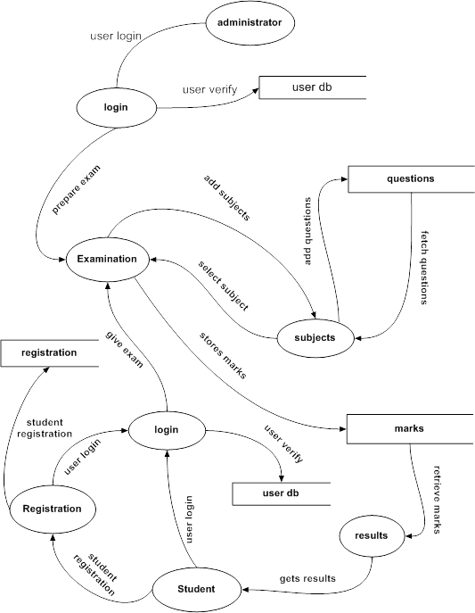*DATAFLOW DIAGRAMS*

**ACTIVITY DIAGRAM**

Activity diagram is basically a flowchart to represent the flow from one activity to another activity. The activity can be described as an operation of the system.

The control flow is drawn from one operation to another. This flow can be sequential, branched, or concurrent. Activity diagrams deal with all type of flow control by using different elements such as fork, join, etc.

Activity is a particular operation of the system. They are used to construct the executable system by using forward and reverse engineering techniques.

**The purpose of an activity diagram is:**

* To Draw the activity flow of a system.
* Describe the sequence from one activity to another.
* Describe the parallel, branched and concurrent flow of the system.

**Activity Diagram consists of following elements –**

* Activities
* Association
* Conditions
* Constraints

Activity diagram is suitable for modeling the activity flow of the system. Activity diagram also captures these systems and describes the flow from one system to another. This specific usage is not available in other diagrams. These systems can be database, external queues, or any other system.

**Activity diagram can be used for –**

* Modeling workflow by using activities.
* Modeling business requirements.
* High level understanding of the system's functionalities.
* Investigating business requirements at a later stage.

**ACTIVITY DIAGRAM:**

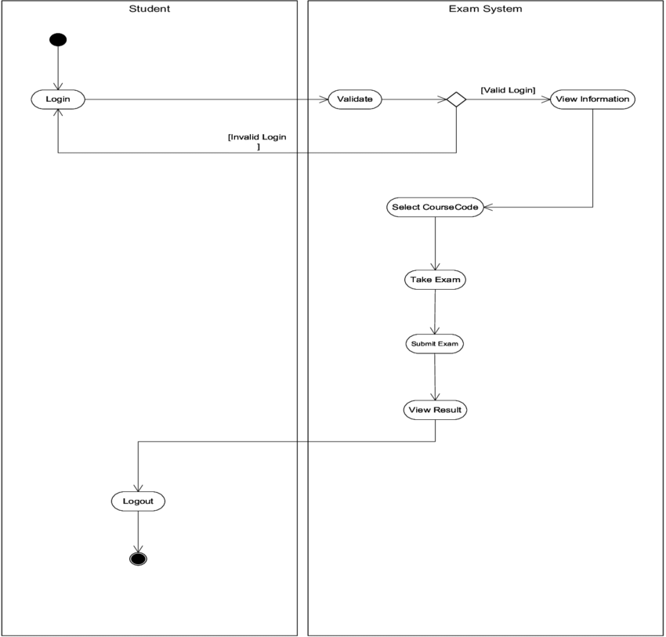

*ACTIVITY DIAGRAM*

**OBJECT DIAGRAM**

An object diagram in the unified modeling language (uml) is a diagram that shows a complete or partial view of the structure of a model system at a specific time.

**OVERVIEW**

Object diagrams are derived from class diagrams so object diagrams are dependent upon class diagram.

Object diagrams represent an instance of a class diagram. The basic concepts are similar for class diagrams and object diagrams. Object diagrams also represent the static view of a system but this static view is a snapshot of the system at a particular moment.

Object diagrams are used to render a set of objects and their relationships as an instance

**PURPOSE**

The purpose of a diagram should be understood clearly to implement i practically. The purposes of object diagrams are similar to class diagrams.

The difference is that a class diagram represents an abstract model consisting of classes and their relationships. But an object diagram represents an instance at a particular moment which is concrete in nature.

It means the object diagram is closer to the actual system behavior. The purpose is to capture the static view of a system at a particular moment.

**SO, THE PURPOSE OF THE OBJECT DIAGRAM CAN BE SUMMARIZED AS:**

* Forward and reverse engineering.
* Object relationships of a system.
* Static view of an interaction.
* Understand object behavior and their relationship from practical perspective.

**OBJECT DIAGRAM:**

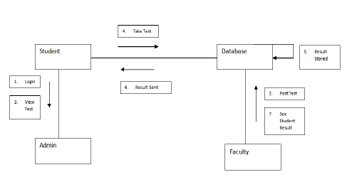*OBJECT DIAGRAM*

**SEQUENCE DIAGRAM**

Sequence diagram emphasizes on time sequence of messages and collaboration diagram emphasizes on the structural organization of the objects that send and receive messages.

**OVERVIEW:**

From the name interaction it is clear that the diagram is used to describe some type of behavior interactions among the different elements in the model. So this interaction is a part of dynamic behavior of system.

The interactive behavior is represented in uml by two diagrams known as sequence diagram and collaboration diagram. The basic purposes of both the diagrams are similar

**PURPOSE:**

The purposes of interaction diagrams are to visualize the interactive behavior of the system now visualizing interaction is a difficult task. So the solution is to use different types of models to capture the different aspects of the interaction.

That is why sequence and collaboration diagrams are used to capture dynamic nature but from different angle.

**SO, THE PURPOSES OF INTERACTION DIAGRAM CAN BE DESCRIBED AS:**

* To capture dynamic behavior of a system.
* To describe the message flow in the system.
* To describe structural organization of the objects
* To describe interaction among.

**SEQUENCE DIAGRAM:**

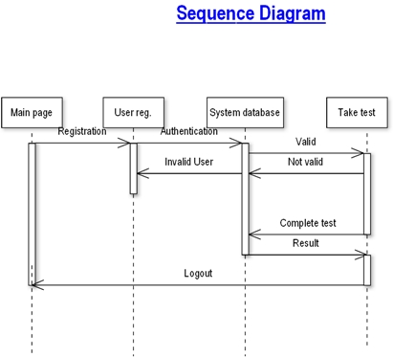*SEQUENCE DIAGRAM*

**CLASS DIAGRAM**

A class diagram in the unified modeling language (uml) is a type of static structure diagram that describes the structure of a system by showing the system's classes, their attributes operations (or methods, and the relationships among objects.

**OVERVIEW:**

The class diagram is a static diagram. It represents the static view of an application. Class diagram is not only used for visualizing, describing and documenting different aspects of a system but also for constructing executable code of the software application.

The class diagram describes the attributes and operations of a class and also the constraints imposed on the system. The class diagrams are widely used in the modeling of object-oriented systems because they are the only uml diagrams which can be mapped directly with object-oriented languages.

The class diagram shows a collection of classes, interfaces, associations, collaborations and constraints. It is also known as a structural diagram.

**PURPOSE:**

The purpose of the class diagram is to model the static view of an application. The class diagrams are the only diagrams which can be directly mapped with object-oriented languages and thus widely used at the time of construction.

The uml diagrams like activity diagram, sequence diagram can only give the sequence flow of the application but class diagram is a bit different. So, it is the most popular uml diagram in the coder community.

**SO, THE PURPOSE OF THE CLASS DIAGRAM CAN BE SUMMARIZED AS:**

* Analysis and design of the static view of an application.
* Forward and reverse engineering.

**CASS DIAGRAM:**



*CLASS DIAGRAM*

**USECASE DIAGRAM**

A use case diagram at its simplest is representation of a user’s interaction with the system that shown the relationship between the user and the different use cases in which the user in involved. A use case diagram can identify the different types of users of a system and different use cases and will often be accompanied by other types of diagrams as well.

**OVERVIEW:**

To modal a system the most important aspect is to capture the dynamic behavior. To clarify a bit in detail, dynamic behavior means the behavior of the system when it running/operating.

So, on static behavior is not sufficient to model system rather dynamic behavior is more at than important static behavior, in uml there are five diagrams available to model dynamic nature and use case diagram is one of them. Now as we have to discuss that the use case diagram is dynamic ne there should be some metal or external factors for making the interaction.

The internal and external agents are known as actors. So, use case diagrams are consists of actors, cases and their relationships. He diagram is used to model the system/subsystem of an application. A single use case diagram captures a particular functionality of a system.

So, to model the entire system numbers of use case diagrams are used

**PURPOSE:**

The purpose of use case diagram is to capture the dynamic aspect of a system. But this definition is 100 generics to describe the purpose.

Because other four diagrams (activity, sequence, collaboration and state chart) are also having the same purpose. So, we will look into some specific purpose which will distinguish it from other four diagrams.

Use case diagrams are used to gather the requirements of a system including internal and external influences. These requirements are mostly design requirements. So, when a system is analyzed to gather its functionalities use cases are prepared and actors are identified.

Now when the initial task is complete use case diagram are modeled to present the outside view.

**SO, IN BRIEF, THE PURPOSE OF USE CASE DIAGRAMS CAN BE AS FOLLOWS:**

* USED TO GATHER REQUIREMENT OF A SYSTEM.
* USED TO GATHER AN OUTSIDE VIEW OF A SYSTEM.
* IDENTIFY EXTERNAL AND INTERNAL FACTOR INFLUENCING THE SYSTEM.
* SHOW THE INTERACTING AMONG THE REQUIREMENTS ARE ACTORS.

**USECASE DIAGRAM:**



*USECASE DIAGRAM*

**16.SCEERNSHOT**

* **USER HOME PAGE**

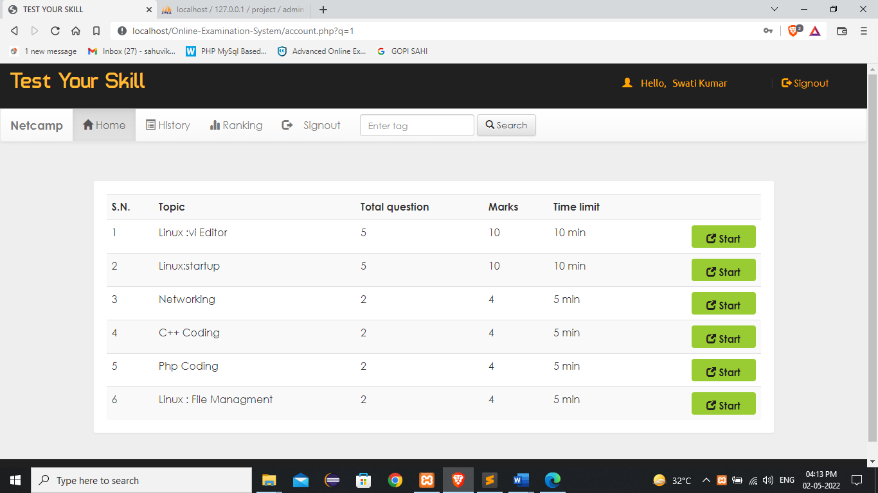

* **USER HISTORY PAGE**

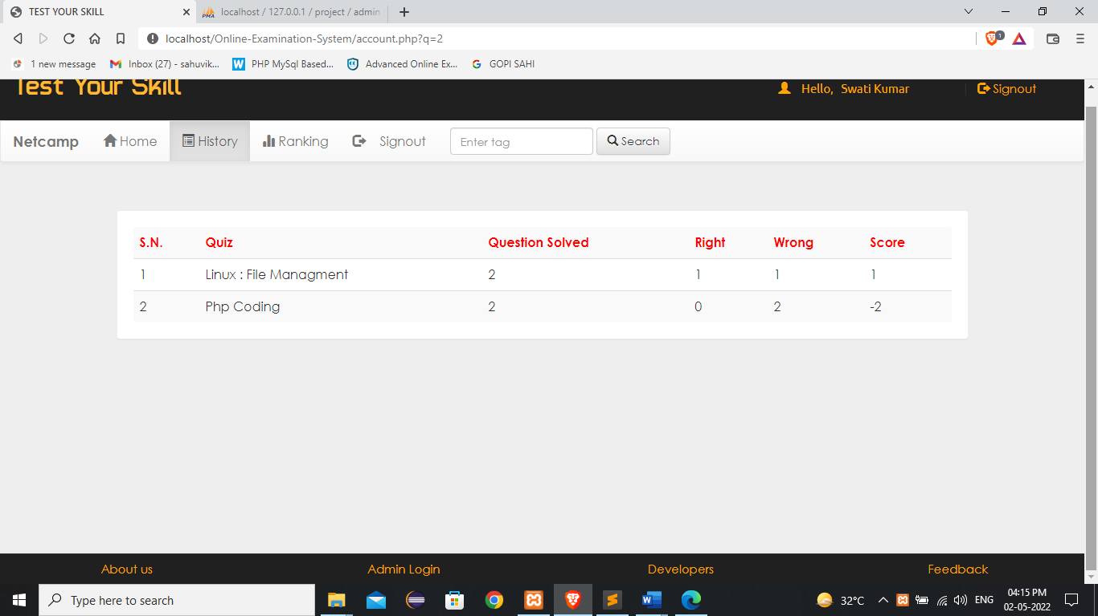

* **ADMIN DETAIL” S PAGE**

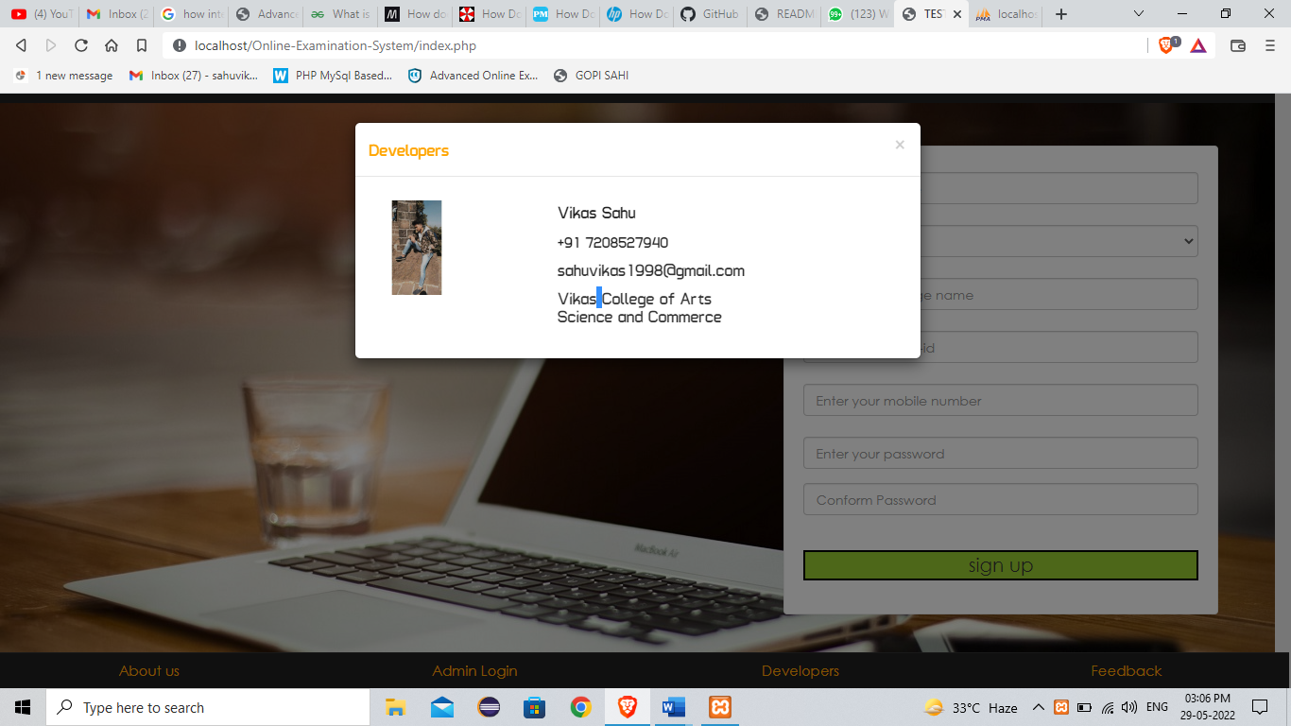

* **ADMIN LOGIN PAGE**

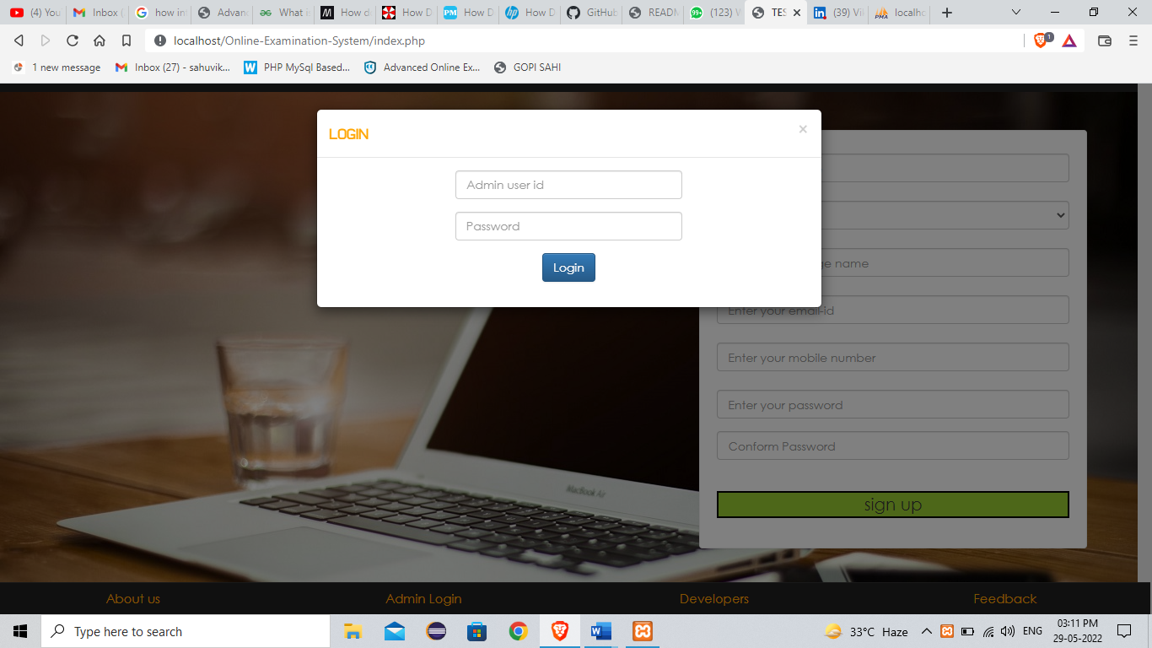

* **LIST OF USERS IN ADMIN PAGE**

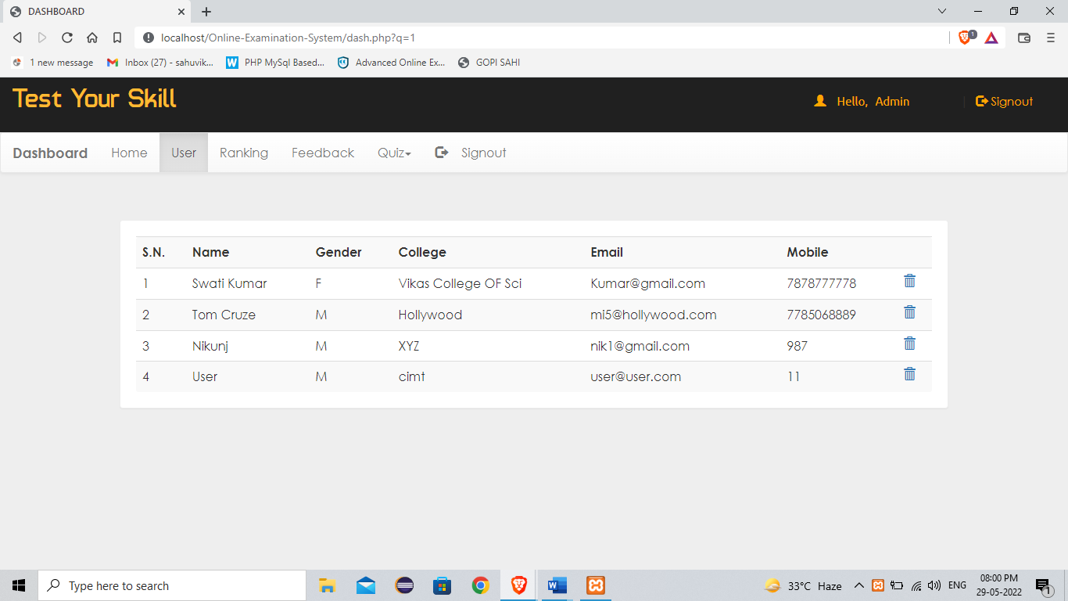

* **CREATING NEW TEST IN ADMIN PAGE**

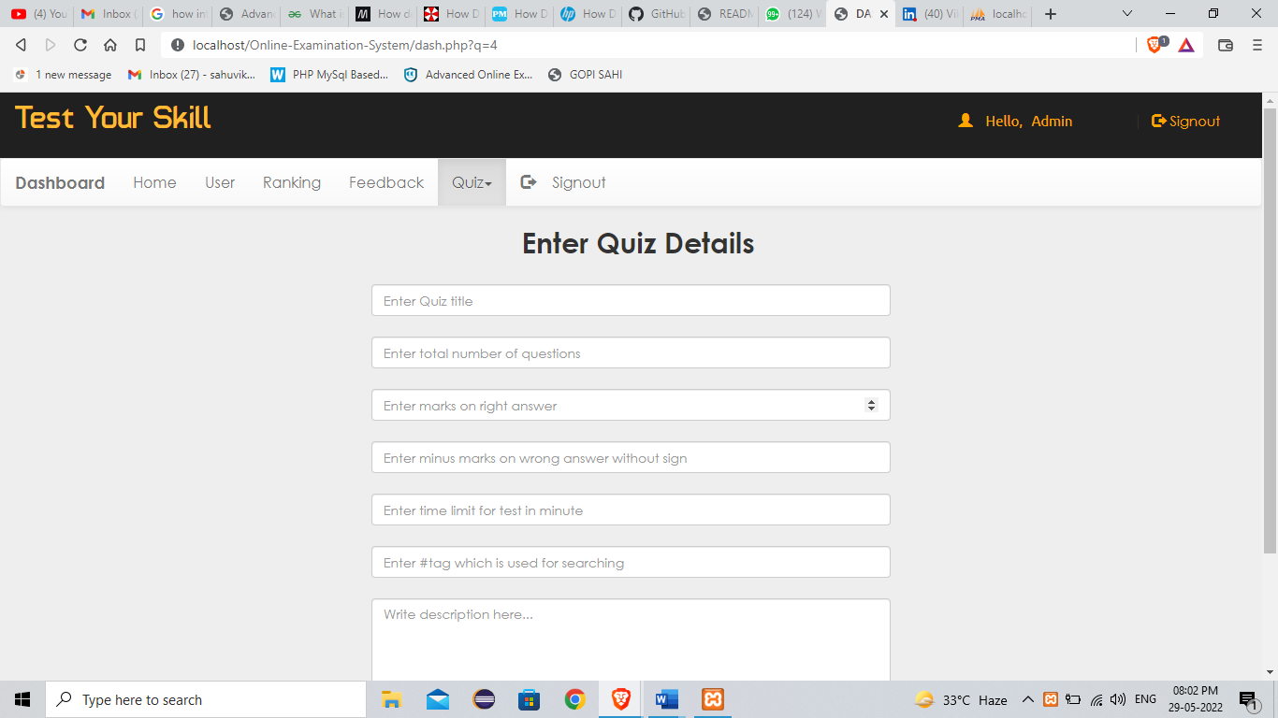

* **REMOVING TEST IN ADMIN PAGE**

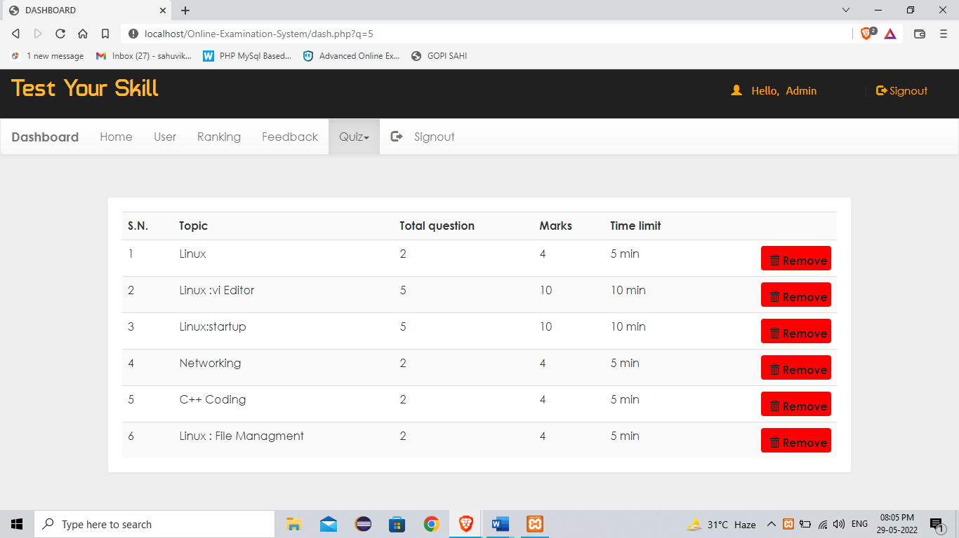

* **STUDENT RANKING PAGE**

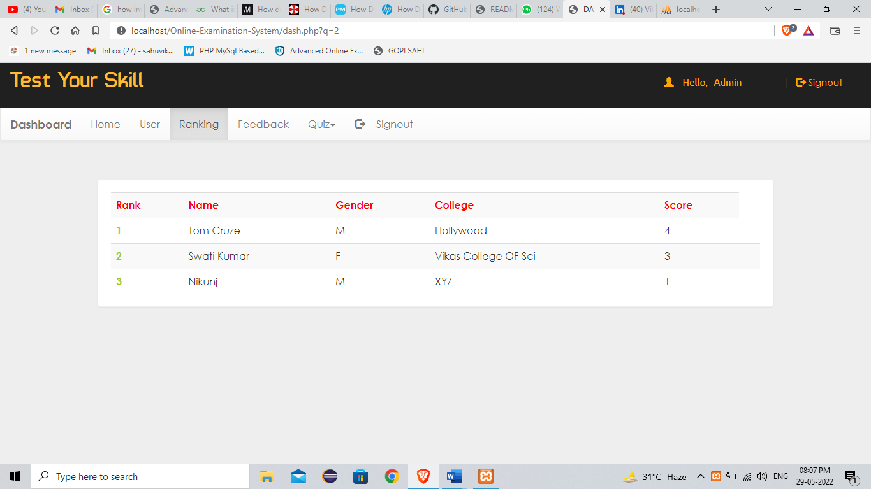

**17.FUTURE WORK**

This application avoids the manual work and the problems concern with it. It is an easy way to obtain the information regarding the different scheduled examinations information that are

Currently issued.

Well, I have worked hard in order to present an improved website better than the existing one’s regarding the information about the various activities. Still, we found out that the project can be done in a better way. Primarily, when I request information about a particular schedule it just shows the exam date and platform. So, after getting the information we can get access to the online exam.

* User authentication via login and signup
* User should able to print result.
* Camera access while giving test.
* AUTH guard implementation.
* Email services should we able.

**18.CONCLUSION**

The package was designed in such a way that future modifications can be done easily. The following conclusions can be deduced from the development of the project.

* Automation of the entire system improves the efficiency
* It provides a friendly graphical user interface which proves to be better when compared to the existing system.
* It gives appropriate access to the authorized users depending on their permissions.
* It effectively overcomes the delay in communications.
* Updating of information becomes so easier.
* System security, data security and reliability are the striking features.
* The System has adequate scope for modification in future if it is necessary.

**19.BIBLOGRAPHY**

The following books were referred during the analysis and execution phase of the project

**Books Referred:**

* BEGINNING PHP 5 ---DAVE MERCER
* BLACK BOOK HTML ---WILEY DREAMTECH
* PHP AND MYSQL WEB DEVELOPMENT --- LUKEWELLING, LAURA
* MICROSOFT SQL SERVER-2000 ---RANKIN, PAUL & JENSEN
* SQL SERVER-2000 ---DUSAN PETKOVIC
* PHP IN A NUTSHELL --- PAUL HUDSON

**SITE REFERRED:**

* <https://www.w3schools.com/>
* https://www.tutorialspoint.com/index.htm
* <https://www.mysqltutorial.org/>
* <https://www.geeksforgeeks.org/>
* <https://www.php.net/>
* <https://www.google.co.in/>
* <https://www.developphp.com/>